# Project Details

Objective: In this project you work for Central Park, a fictitious national park. The application you create allows Pokémon trainers to track Pokémon’s that are wandering in the park.

App consist of two objects:

* Contacts (Standard)
* Pokémon (Custom)

## Relationship:

• Contacts (Supervisor) - Parent Object of Pokémon

Object. • Pokemon – Standard object having master-detail relationship with Contact (parent) object. Fields of

Pokemon object are: -

• Name (text)

• Height (Number)

• Location (Geolocation)

• Weight (Number)

• Contact (master-detail)

## Create an Lightning App called – Pokemon Tracker

1. Go to app manager and click ‘ New Lightning App’
2. Add the name, logo and color of the app
3. Add the items you want to show in your apps navbar. I’m selecting Contacts for now as it will be used further in our app.
4. Add ‘System Administrator’ profile
5. 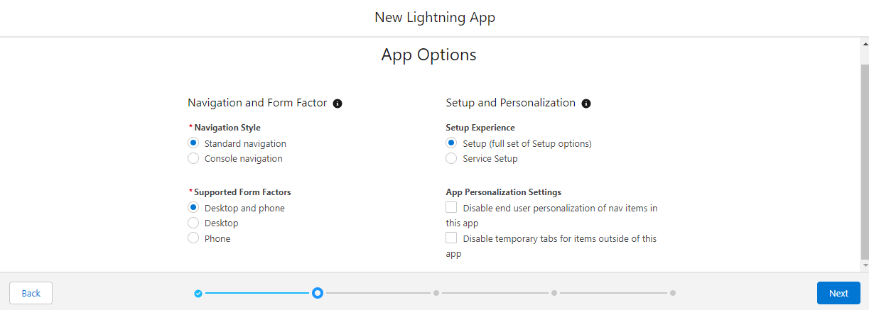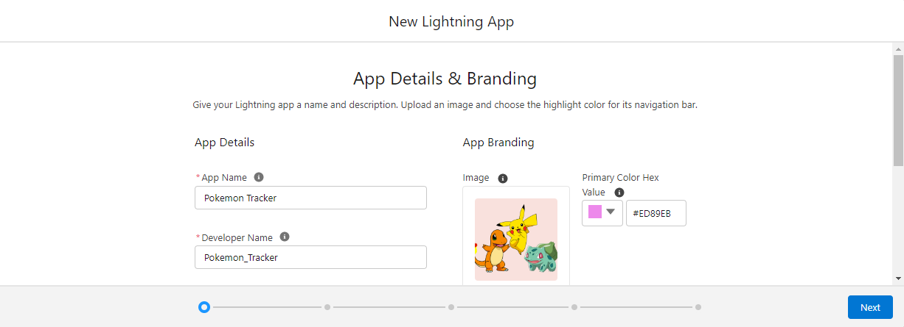Click ‘Finish and save’
6. 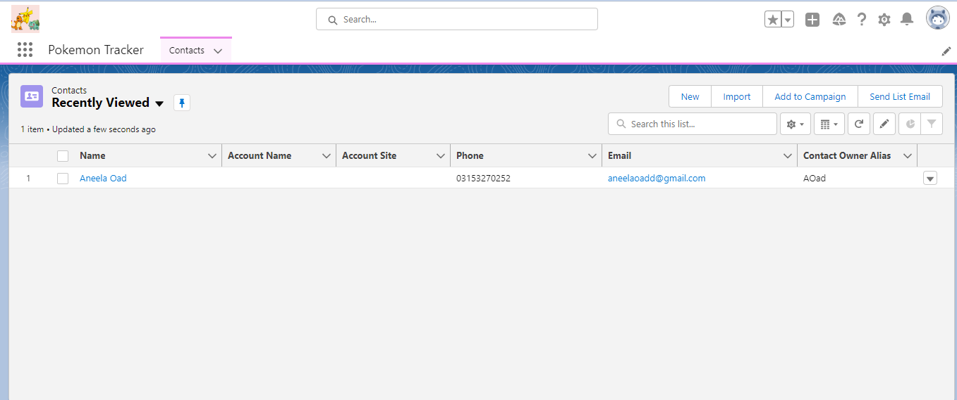App is ready
7. Create 4 contacts of pokemon trainers
8. Now create Pokemon custom object and a tab as well

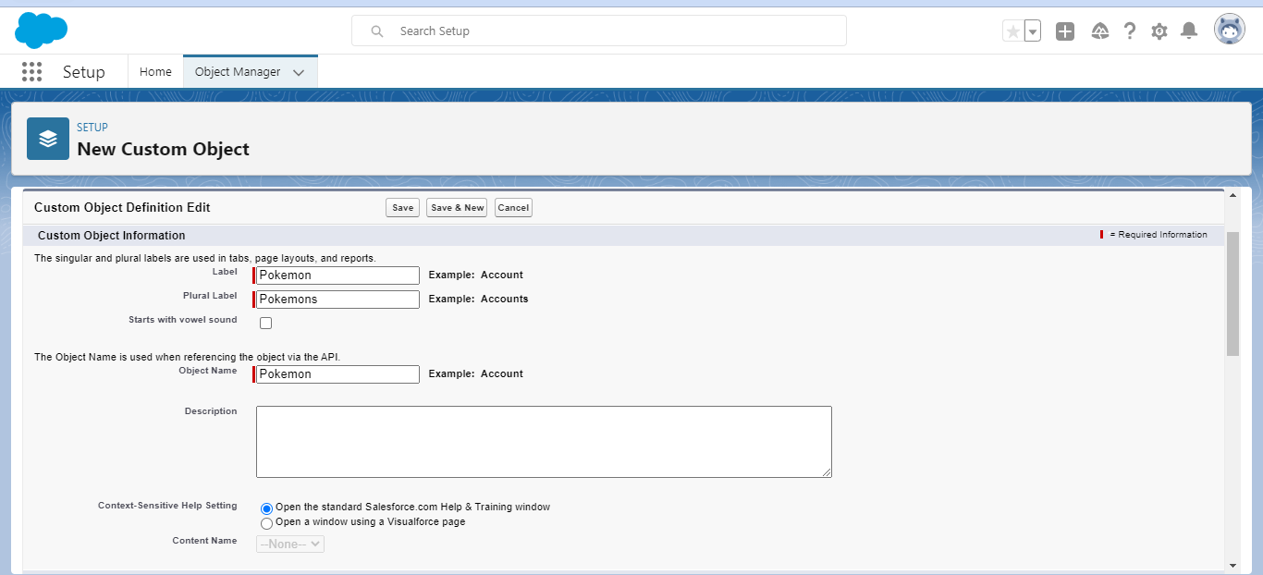

1. Map in LWC
2. Create LWC

• Create the Pokemon Location Component which shows the location of pokemons called - PokemonTracker

* Import a getRecord & getFieldValue adapter that allow us to use the Lightning Data Service to retrieve records & fields without having to write Apex.

• Create the Pokemon Trainer Component (record-form).

Pokemon Name ↑ Arbokk Charizaard Crobatt Pikachuu Scytherr Staryuu ✓

Height 119 150 110 123 140 120

Trainer Jamess Ash ketchumm Brock K Ash ketchumm Ash ketchumm Mysty M

Location (Latitude) 45.372708 45.342760 45.392717 45.342761 45.302760 45.332761

Location (Longitude) 5.719162 5.727150 5.791562 5.707158 5.719151 5.717158 ✓

Weight 250 145 120 121 230 160

1. PokemonCardList LWC.

* Apex class: To fetch the pokemons details